**Hints to Code Tic Tac Toe Game**

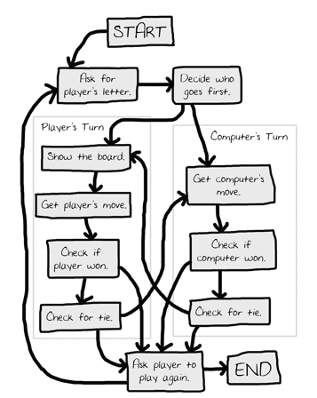

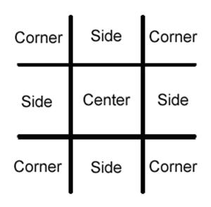

Sample Run-

|  |
| --- |
| Welcome to Tic Tac Toe!  Do you want to be X or O?  **X**  The computer will go first.     |   |   O |   |     |   |  -----------     |   |     |   |     |   |  -----------     |   |     |   |     |   |  What is your next move? (1-9)  **3**     |   |   O |   |     |   |  -----------     |   |     |   |     |   |  -----------     |   |   O |   | X     |   |  What is your next move? (1-9)  **4**     |   |   O |   | O     |   |  -----------     |   |   X |   |     |   |  -----------     |   |   O |   | X     |   |  What is your next move? (1-9)  **5**     |   |   O | O | O     |   |  -----------     |   |   X | X |     |   |  -----------     |   |   O |   | X     |   |  The computer has beaten you! You lose.  Do you want to play again? (yes or no)  **no** |